DROP TABLE O_EMP cascade constraints;

DROP TABLE O_DEPT cascade constraints;

DROP TABLE O_BONUS cascade constraints;

DROP TABLE O_SALGRADE cascade constraints;

DROP TABLE O_ITEM cascade constraints;

DROP TABLE O_PRICE cascade constraints;

DROP TABLE O_PRODUCT cascade constraints;

DROP TABLE O_ORD cascade constraints;

DROP TABLE O_CUSTOMER cascade constraints;

DROP VIEW O_SALES;

DROP SEQUENCE O_ORDID ;

DROP SEQUENCE O_CUSTID;

DROP SEQUENCE O_PRODID;

CREATE TABLE O_DEPT (

DEPTNO NUMBER(2) NOT NULL,

DNAME VARCHAR2(14),

LOC VARCHAR2(13),

CONSTRAINT O_DEPT_PRIMARY_KEY PRIMARY KEY (DEPTNO));

INSERT INTO O_DEPT VALUES (10,'ACCOUNTING','NEW YORK');

INSERT INTO O_DEPT VALUES (20,'RESEARCH','DALLAS');

INSERT INTO O_DEPT VALUES (30,'SALES','CHICAGO');

INSERT INTO O_DEPT VALUES (40,'OPERATIONS','BOSTON');

CREATE TABLE O_EMP (

EMPNO NUMBER(4) NOT NULL,

ENAME VARCHAR2(10),

JOB VARCHAR2(9),

MGR NUMBER(4) CONSTRAINT O_EMP_MGR_FK REFERENCES O_EMP (EMPNO),

HIREDATE DATE,

SAL NUMBER(7,2),

COMM NUMBER(7,2),

DEPTNO NUMBER(2) NOT NULL,

CONSTRAINT O_EMP_DEPTNO_FK FOREIGN KEY (DEPTNO) REFERENCES O_DEPT (DEPTNO),

CONSTRAINT O_EMP_EMPNO_PK PRIMARY KEY (EMPNO));

INSERT INTO O_EMP VALUES (7839,'KING','PRESIDENT',NULL,TO_DATE('17-NOV-1981','DD-MON-YYYY'),5000,NULL,10);

INSERT INTO O_EMP VALUES (7698,'BLAKE','MANAGER',7839,TO_DATE('1-MAY-1981','DD-MON-YYYY'),2850,NULL,30);

INSERT INTO O_EMP VALUES (7782,'CLARK','MANAGER',7839,TO_DATE('9-JUN-1981','DD-MON-YYYY'),2450,NULL,10);

INSERT INTO O_EMP VALUES (7566,'JONES','MANAGER',7839,TO_DATE('2-APR-1981','DD-MON-YYYY'),2975,NULL,20);

INSERT INTO O_EMP VALUES (7654,'MARTIN','SALESMAN',7698,TO_DATE('28-SEP-1981','DD-MON-YYYY'),1250,1400,30);

INSERT INTO O_EMP VALUES (7499,'ALLEN','SALESMAN',7698,TO_DATE('20-FEB-1981','DD-MON-YYYY'),1600,300,30);

INSERT INTO O_EMP VALUES (7844,'TURNER','SALESMAN',7698,TO_DATE('8-SEP-1981','DD-MON-YYYY'),1500,0,30);

INSERT INTO O_EMP VALUES (7900,'JAMES','CLERK',7698,TO_DATE('3-DEC-1981','DD-MON-YYYY'),950,NULL,30);

INSERT INTO O_EMP VALUES (7521,'WARD','SALESMAN',7698,TO_DATE('22-FEB-1981','DD-MON-YYYY'),1250,500,30);

INSERT INTO O_EMP VALUES (7902,'FORD','ANALYST',7566,TO_DATE('3-DEC-1981','DD-MON-YYYY'),3000,NULL,20);

INSERT INTO O_EMP VALUES (7369,'SMITH','CLERK',7902,TO_DATE('17-DEC-1980','DD-MON-YYYY'),800,NULL,20);

INSERT INTO O_EMP VALUES (7788,'SCOTT','ANALYST',7566,TO_DATE('09-DEC-1982','DD-MON-YYYY'),3000,NULL,20);

INSERT INTO O_EMP VALUES (7876,'ADAMS','CLERK',7788,TO_DATE('12-JAN-1983','DD-MON-YYYY'),1100,NULL,20);

INSERT INTO O_EMP VALUES (7934,'MILLER','CLERK',7782,TO_DATE('23-JAN-1982','DD-MON-YYYY'),1300,NULL,10);

CREATE TABLE O_BONUS (

ENAME VARCHAR2(10)references o_emp(ename),

JOB VARCHAR2(9),

SAL NUMBER,

COMM NUMBER);

CREATE TABLE O_SALGRADE (

GRADE NUMBER,

LOSAL NUMBER,

HISAL NUMBER);

INSERT INTO O_SALGRADE VALUES (1,700,1200);

INSERT INTO O_SALGRADE VALUES (2,1201,1400);

INSERT INTO O_SALGRADE VALUES (3,1401,2000);

INSERT INTO O_SALGRADE VALUES (4,2001,3000);

INSERT INTO O_SALGRADE VALUES (5,3001,9999);

CREATE TABLE O_CUSTOMER (

CUSTID NUMBER (6) NOT NULL,

NAME VARCHAR2 (45),

ADDRESS VARCHAR2 (40),

CITY VARCHAR2 (30),

STATE VARCHAR2 (2),

ZIP VARCHAR2 (9),

AREA NUMBER (3),

PHONE VARCHAR2 (9),

REPID NUMBER (4) NOT NULL references o_emp(empno),

CREDITLIMIT NUMBER (9,2),

COMMENTS LONG,

CONSTRAINT O_CUSTOMER_CUSTID_PK PRIMARY KEY (CUSTID),

CONSTRAINT O_CUSTOMER_CUSTID_CK CHECK (CUSTID > 0));

CREATE TABLE O_ORD (

ORDID NUMBER (4) NOT NULL,

ORDERDATE DATE,

COMMPLAN VARCHAR2 (1),

CUSTID NUMBER (6) NOT NULL,

SHIPDATE DATE,

TOTAL NUMBER (8,2) CONSTRAINT O_ORD_TOTAL_CK CHECK (TOTAL >= 0),

CONSTRAINT O_ORD_CUSTID_FK FOREIGN KEY (CUSTID) REFERENCES O_CUSTOMER (CUSTID),

CONSTRAINT O_ORD_ORDID_PK PRIMARY KEY (ORDID));

CREATE TABLE O_PRODUCT (

PRODID NUMBER (6) CONSTRAINT O_PRODID_PK PRIMARY KEY,

DESCRIP VARCHAR2 (30));

CREATE TABLE O_ITEM (

ORDID NUMBER (4) NOT NULL,

ITEMID NUMBER (4) NOT NULL,

PRODID NUMBER (6)references o_product(prodid),

ACTUALPRICE NUMBER (8,2),

QTY NUMBER (8),

ITEMTOT NUMBER (8,2),

CONSTRAINT O_ITEM_ORDID_FK FOREIGN KEY (ORDID) REFERENCES O_ORD (ORDID),

CONSTRAINT O_ITEM_ORDID_ITEMID_PK PRIMARY KEY (ORDID,ITEMID));

CREATE TABLE O_PRICE (

PRODID NUMBER (6) NOT NULL references o_product(prodid),

STDPRICE NUMBER (8,2),

MINPRICE NUMBER (8,2),

STARTDATE DATE,

ENDDATE DATE);

INSERT INTO O_CUSTOMER (ZIP, STATE, REPID, PHONE, NAME, CUSTID, CREDITLIMIT,

CITY, AREA, ADDRESS, COMMENTS)

VALUES ('96711', 'CA', '7844', '598-6609',

'JOCKSPORTS',

'100', '5000', 'BELMONT', '415', '345 VIEWRIDGE',

'Very friendly people to work with -- sales rep likes to be called Mike.');

INSERT INTO O_CUSTOMER (ZIP, STATE, REPID, PHONE, NAME, CUSTID, CREDITLIMIT,

CITY, AREA, ADDRESS, COMMENTS)

VALUES ('94061', 'CA', '7521', '368-1223',

'TKB SPORT SHOP',

'101', '10000', 'REDWOOD CITY', '415', '490 BOLI RD.',

'Rep called 5/8 about change in order - contact shipping.');

INSERT INTO O_CUSTOMER (ZIP, STATE, REPID, PHONE, NAME, CUSTID, CREDITLIMIT,

CITY, AREA, ADDRESS, COMMENTS)

VALUES ('95133', 'CA', '7654', '644-3341',

'VOLLYRITE',

'102', '7000', 'BURLINGAME', '415', '9722 HAMILTON',

'Company doing heavy promotion beginning 10/89. Prepare for large orders during

winter.');

INSERT INTO O_CUSTOMER (ZIP, STATE, REPID, PHONE, NAME, CUSTID, CREDITLIMIT,

CITY, AREA, ADDRESS, COMMENTS)

VALUES ('97544', 'CA', '7521', '677-9312',

'JUST TENNIS',

'103', '3000', 'BURLINGAME', '415', 'HILLVIEW MALL',

'Contact rep about new line of tennis rackets.');

INSERT INTO O_CUSTOMER (ZIP, STATE, REPID, PHONE, NAME, CUSTID, CREDITLIMIT,

CITY, AREA, ADDRESS, COMMENTS)

VALUES ('93301', 'CA', '7499', '996-2323',

'EVERY MOUNTAIN',

'104', '10000', 'CUPERTINO', '408', '574 SUYYYYY RD.',

'Customer with high market share (23%) due to aggressive advertising.');

INSERT INTO O_CUSTOMER (ZIP, STATE, REPID, PHONE, NAME, CUSTID, CREDITLIMIT,

CITY, AREA, ADDRESS, COMMENTS)

VALUES ('91003', 'CA', '7844', '376-9966',

'K + T SPORTS',

'105', '5000', 'SANTA CLARA', '408', '3476 EL PASEO',

'Tends to order large amounts of merchandise at once. Accounting is considering

raising their credit limit. Usually pays on time.');

INSERT INTO O_CUSTOMER (ZIP, STATE, REPID, PHONE, NAME, CUSTID, CREDITLIMIT,

CITY, AREA, ADDRESS, COMMENTS)

VALUES ('94301', 'CA', '7521', '364-9777',

'SHAPE UP',

'106', '6000', 'PALO ALTO', '415', '908 SEQUOIA',

'Support intensive. Orders small amounts (< 800) of merchandise at a time.');

INSERT INTO O_CUSTOMER (ZIP, STATE, REPID, PHONE, NAME, CUSTID, CREDITLIMIT,

CITY, AREA, ADDRESS, COMMENTS)

VALUES ('93301', 'CA', '7499', '967-4398',

'WOMENS SPORTS',

'107', '10000', 'SUNNYVALE', '408', 'VALCO VILLAGE',

'First sporting goods store geared exclusively towards women. Unusual promotion

al style and very willing to take chances towards new products!');

INSERT INTO O_CUSTOMER (ZIP, STATE, REPID, PHONE, NAME, CUSTID, CREDITLIMIT,

CITY, AREA, ADDRESS, COMMENTS)

VALUES ('55649', 'MN', '7844', '566-9123',

'NORTH WOODS HEALTH AND FITNESS SUPPLY CENTER',

'108', '8000', 'HIBBING', '612', '98 LONE PINE WAY', '');

INSERT INTO O_ORD (TOTAL, SHIPDATE, ORDID, ORDERDATE, CUSTID, COMMPLAN)

VALUES ('101.4', TO_DATE('08-JAN-1987','DD-MON-YYYY'), '610', TO_DATE('07-JAN-1987','DD-MON-YYYY'), '101', 'A');

INSERT INTO O_ORD (TOTAL, SHIPDATE, ORDID, ORDERDATE, CUSTID, COMMPLAN)

VALUES ('45', TO_DATE('11-JAN-1987','DD-MON-YYYY'), '611', TO_DATE('11-JAN-1987','DD-MON-YYYY'), '102', 'B');

INSERT INTO O_ORD (TOTAL, SHIPDATE, ORDID, ORDERDATE, CUSTID, COMMPLAN)

VALUES ('5860', TO_DATE('20-JAN-1987','DD-MON-YYYY'), '612', TO_DATE('15-JAN-1987','DD-MON-YYYY'), '104', 'C');

INSERT INTO O_ORD (TOTAL, SHIPDATE, ORDID, ORDERDATE, CUSTID, COMMPLAN)

VALUES ('2.4', TO_DATE('30-MAY-1986','DD-MON-YYYY'), '601', TO_DATE('01-MAY-1986','DD-MON-YYYY'), '106', 'A');

INSERT INTO O_ORD (TOTAL, SHIPDATE, ORDID, ORDERDATE, CUSTID, COMMPLAN)

VALUES ('56', TO_DATE('20-JUN-1986','DD-MON-YYYY'), '602', TO_DATE('05-JUN-1986','DD-MON-YYYY'), '102', 'B');

INSERT INTO O_ORD (TOTAL, SHIPDATE, ORDID, ORDERDATE, CUSTID, COMMPLAN)

VALUES ('698', TO_DATE('30-JUN-1986','DD-MON-YYYY'), '604', TO_DATE('15-JUN-1986','DD-MON-YYYY'), '106', 'A');

INSERT INTO O_ORD (TOTAL, SHIPDATE, ORDID, ORDERDATE, CUSTID, COMMPLAN)

VALUES ('8324',TO_DATE( '30-JUL-1986','DD-MON-YYYY'), '605', TO_DATE('14-JUL-1986','DD-MON-YYYY'), '106', 'A');

INSERT INTO O_ORD (TOTAL, SHIPDATE, ORDID, ORDERDATE, CUSTID, COMMPLAN)

VALUES ('3.4', TO_DATE('30-JUL-1986','DD-MON-YYYY'), '606', TO_DATE('14-JUL-1986','DD-MON-YYYY'), '100', 'A');

INSERT INTO O_ORD (TOTAL, SHIPDATE, ORDID, ORDERDATE, CUSTID, COMMPLAN)

VALUES ('97.5', TO_DATE('15-AUG-1986','DD-MON-YYYY'), '609', TO_DATE('01-AUG-1986','DD-MON-YYYY'), '100', 'B');

INSERT INTO O_ORD (TOTAL, SHIPDATE, ORDID, ORDERDATE, CUSTID, COMMPLAN)

VALUES ('5.6', TO_DATE('18-JUL-1986','DD-MON-YYYY'), '607', TO_DATE('18-JUL-1986','DD-MON-YYYY'), '104', 'C');

INSERT INTO O_ORD (TOTAL, SHIPDATE, ORDID, ORDERDATE, CUSTID, COMMPLAN)

VALUES ('35.2', TO_DATE('25-JUL-1986','DD-MON-YYYY'), '608', TO_DATE('25-JUL-1986','DD-MON-YYYY'), '104', 'C');

INSERT INTO O_ORD (TOTAL, SHIPDATE, ORDID, ORDERDATE, CUSTID, COMMPLAN)

VALUES ('224', TO_DATE('05-JUN-1986','DD-MON-YYYY'), '603', TO_DATE('05-JUN-1986','DD-MON-YYYY'), '102', '');

INSERT INTO O_ORD (TOTAL, SHIPDATE, ORDID, ORDERDATE, CUSTID, COMMPLAN)

VALUES ('4450', TO_DATE('12-MAR-1987','DD-MON-YYYY'), '620', TO_DATE('12-MAR-1987','DD-MON-YYYY'), '100', '');

INSERT INTO O_ORD (TOTAL, SHIPDATE, ORDID, ORDERDATE, CUSTID, COMMPLAN)

VALUES ('6400', TO_DATE('01-FEB-1987','DD-MON-YYYY'), '613', TO_DATE('01-FEB-1987','DD-MON-YYYY'), '108', '');

INSERT INTO O_ORD (TOTAL, SHIPDATE, ORDID, ORDERDATE, CUSTID, COMMPLAN)

VALUES ('23940', TO_DATE('05-FEB-1987','DD-MON-YYYY'), '614', TO_DATE('01-FEB-1987','DD-MON-YYYY'), '102', '');

INSERT INTO O_ORD (TOTAL, SHIPDATE, ORDID, ORDERDATE, CUSTID, COMMPLAN)

VALUES ('764', TO_DATE('10-FEB-1987','DD-MON-YYYY'), '616', TO_DATE('03-FEB-1987','DD-MON-YYYY'), '103', '');

INSERT INTO O_ORD (TOTAL, SHIPDATE, ORDID, ORDERDATE, CUSTID, COMMPLAN)

VALUES ('1260', TO_DATE('04-FEB-1987','DD-MON-YYYY'), '619', TO_DATE('22-FEB-1987','DD-MON-YYYY'), '104', '');

INSERT INTO O_ORD (TOTAL, SHIPDATE, ORDID, ORDERDATE, CUSTID, COMMPLAN)

VALUES ('46370', TO_DATE('03-MAR-1987','DD-MON-YYYY'), '617', TO_DATE('05-FEB-1987','DD-MON-YYYY'), '105', '');

INSERT INTO O_ORD (TOTAL, SHIPDATE, ORDID, ORDERDATE, CUSTID, COMMPLAN)

VALUES ('710', TO_DATE('06-FEB-1987','DD-MON-YYYY'), '615', TO_DATE('01-FEB-1987','DD-MON-YYYY'), '107', '');

INSERT INTO O_ORD (TOTAL, SHIPDATE, ORDID, ORDERDATE, CUSTID, COMMPLAN)

VALUES ('3510.5', TO_DATE('06-MAR-1987','DD-MON-YYYY'), '618', TO_DATE('15-FEB-1987','DD-MON-YYYY'), '102', 'A');

INSERT INTO O_ORD (TOTAL, SHIPDATE, ORDID, ORDERDATE, CUSTID, COMMPLAN)

VALUES ('730', TO_DATE('01-JAN-1987','DD-MON-YYYY'), '621', TO_DATE('15-MAR-1987','DD-MON-YYYY'), '100', 'A');

INSERT INTO O_PRODUCT (PRODID, DESCRIP)

VALUES ('100860', 'ACE TENNIS RACKET I');

INSERT INTO O_PRODUCT (PRODID, DESCRIP)

VALUES ('100861', 'ACE TENNIS RACKET II');

INSERT INTO O_PRODUCT (PRODID, DESCRIP)

VALUES ('100870', 'ACE TENNIS BALLS-3 PACK');

INSERT INTO O_PRODUCT (PRODID, DESCRIP)

VALUES ('100871', 'ACE TENNIS BALLS-6 PACK');

INSERT INTO O_PRODUCT (PRODID, DESCRIP)

VALUES ('100890', 'ACE TENNIS NET');

INSERT INTO O_PRODUCT (PRODID, DESCRIP)

VALUES ('101860', 'SP TENNIS RACKET');

INSERT INTO O_PRODUCT (PRODID, DESCRIP)

VALUES ('101863', 'SP JUNIOR RACKET');

INSERT INTO O_PRODUCT (PRODID, DESCRIP)

VALUES ('102130', 'RH: "GUIDE TO TENNIS"');

INSERT INTO O_PRODUCT (PRODID, DESCRIP)

VALUES ('200376', 'SB ENERGY BAR-6 PACK');

INSERT INTO O_PRODUCT (PRODID, DESCRIP)

VALUES ('200380', 'SB VITA SNACK-6 PACK');

INSERT INTO O_ITEM (QTY, PRODID, ORDID, ITEMTOT, ITEMID, ACTUALPRICE)

VALUES ('1', '100890', '610', '58', '3', '58');

INSERT INTO O_ITEM ( QTY , PRODID , ORDID , ITEMTOT , ITEMID , ACTUALPRICE)

VALUES ( '1', '100861', '611', '45', '1', '45');

INSERT INTO O_ITEM ( QTY , PRODID , ORDID , ITEMTOT , ITEMID , ACTUALPRICE)

VALUES ( '100', '100860', '612', '3000', '1', '30');

INSERT INTO O_ITEM ( QTY , PRODID , ORDID , ITEMTOT , ITEMID , ACTUALPRICE)

VALUES ( '1', '200376', '601', '2.4', '1', '2.4');

INSERT INTO O_ITEM ( QTY , PRODID , ORDID , ITEMTOT , ITEMID , ACTUALPRICE)

VALUES ( '20', '100870', '602', '56', '1', '2.8');

INSERT INTO O_ITEM ( QTY , PRODID , ORDID , ITEMTOT , ITEMID , ACTUALPRICE)

VALUES ( '3', '100890', '604', '174', '1', '58');

INSERT INTO O_ITEM ( QTY , PRODID , ORDID , ITEMTOT , ITEMID , ACTUALPRICE)

VALUES ( '2', '100861', '604', '84', '2', '42');

INSERT INTO O_ITEM ( QTY , PRODID , ORDID , ITEMTOT , ITEMID , ACTUALPRICE)

VALUES ( '10', '100860', '604', '440', '3', '44');

INSERT INTO O_ITEM ( QTY , PRODID , ORDID , ITEMTOT , ITEMID , ACTUALPRICE)

VALUES ( '4', '100860', '603', '224', '2', '56');

INSERT INTO O_ITEM ( QTY , PRODID , ORDID , ITEMTOT , ITEMID , ACTUALPRICE)

VALUES ( '1', '100860', '610', '35', '1', '35');

INSERT INTO O_ITEM ( QTY , PRODID , ORDID , ITEMTOT , ITEMID , ACTUALPRICE)

VALUES ( '3', '100870', '610', '8.4', '2', '2.8');

INSERT INTO O_ITEM ( QTY , PRODID , ORDID , ITEMTOT , ITEMID , ACTUALPRICE)

VALUES ( '200', '200376', '613', '440', '4', '2.2');

INSERT INTO O_ITEM ( QTY , PRODID , ORDID , ITEMTOT , ITEMID , ACTUALPRICE)

VALUES ( '444', '100860', '614', '15540', '1', '35');

INSERT INTO O_ITEM ( QTY , PRODID , ORDID , ITEMTOT , ITEMID , ACTUALPRICE)

VALUES ( '1000', '100870', '614', '2800', '2', '2.8');

INSERT INTO O_ITEM ( QTY , PRODID , ORDID , ITEMTOT , ITEMID , ACTUALPRICE)

VALUES ( '20', '100861', '612', '810', '2', '40.5');

INSERT INTO O_ITEM ( QTY , PRODID , ORDID , ITEMTOT , ITEMID , ACTUALPRICE)

VALUES ('150', '101863', '612', '1500', '3', '10');

INSERT INTO O_ITEM ( QTY , PRODID , ORDID , ITEMTOT , ITEMID , ACTUALPRICE)

VALUES ('10', '100860', '620', '350', '1', '35');

INSERT INTO O_ITEM ( QTY , PRODID , ORDID , ITEMTOT , ITEMID , ACTUALPRICE)

VALUES ('1000', '200376', '620', '2400', '2', '2.4');

INSERT INTO O_ITEM ( QTY , PRODID , ORDID , ITEMTOT , ITEMID , ACTUALPRICE)

VALUES ('500', '102130', '620', '1700', '3', '3.4');

INSERT INTO O_ITEM ( QTY , PRODID , ORDID , ITEMTOT , ITEMID , ACTUALPRICE)

VALUES ( '100', '100871', '613', '560', '1', '5.6');

INSERT INTO O_ITEM ( QTY , PRODID , ORDID , ITEMTOT , ITEMID , ACTUALPRICE)

VALUES ('200', '101860', '613', '4800', '2', '24');

INSERT INTO O_ITEM ( QTY , PRODID , ORDID , ITEMTOT , ITEMID , ACTUALPRICE)

VALUES ('150', '200380', '613', '600', '3', '4');

INSERT INTO O_ITEM ( QTY , PRODID , ORDID , ITEMTOT , ITEMID , ACTUALPRICE)

VALUES ('100', '102130', '619', '340', '3', '3.4');

INSERT INTO O_ITEM ( QTY , PRODID , ORDID , ITEMTOT , ITEMID , ACTUALPRICE)

VALUES ('50', '100860', '617', '1750', '1', '35');

INSERT INTO O_ITEM ( QTY , PRODID , ORDID , ITEMTOT , ITEMID , ACTUALPRICE)

VALUES ('100', '100861', '617', '4500', '2', '45');

INSERT INTO O_ITEM ( QTY , PRODID , ORDID , ITEMTOT , ITEMID , ACTUALPRICE)

VALUES ('1000', '100871', '614', '5600', '3', '5.6');

INSERT INTO O_ITEM ( QTY , PRODID , ORDID , ITEMTOT , ITEMID , ACTUALPRICE)

VALUES ('10', '100861', '616', '450', '1', '45');

INSERT INTO O_ITEM ( QTY , PRODID , ORDID , ITEMTOT , ITEMID , ACTUALPRICE)

VALUES ('50', '100870', '616', '140', '2', '2.8');

INSERT INTO O_ITEM ( QTY , PRODID , ORDID , ITEMTOT , ITEMID , ACTUALPRICE)

VALUES ('2', '100890', '616', '116', '3', '58');

INSERT INTO O_ITEM ( QTY , PRODID , ORDID , ITEMTOT , ITEMID , ACTUALPRICE)

VALUES ('10', '102130', '616', '34', '4', '3.4');

INSERT INTO O_ITEM ( QTY , PRODID , ORDID , ITEMTOT , ITEMID , ACTUALPRICE)

VALUES ('10', '200376' , '616', '24', '5', '2.4');

INSERT INTO O_ITEM ( QTY , PRODID , ORDID , ITEMTOT , ITEMID , ACTUALPRICE)

VALUES ('100', '200380', '619', '400', '1', '4');

INSERT INTO O_ITEM ( QTY , PRODID , ORDID , ITEMTOT , ITEMID , ACTUALPRICE)

VALUES ('100', '200376', '619', '240', '2', '2.4');

INSERT INTO O_ITEM ( QTY , PRODID , ORDID , ITEMTOT , ITEMID , ACTUALPRICE)

VALUES ('4', '100861', '615', '180', '1', '45');

INSERT INTO O_ITEM ( QTY , PRODID , ORDID , ITEMTOT , ITEMID , ACTUALPRICE)

VALUES ('1', '100871', '607', '5.6', '1', '5.6');

INSERT INTO O_ITEM ( QTY , PRODID , ORDID , ITEMTOT , ITEMID , ACTUALPRICE)

VALUES ('100', '100870', '615', '280', '2', '2.8');

INSERT INTO O_ITEM ( QTY , PRODID , ORDID , ITEMTOT , ITEMID , ACTUALPRICE)

VALUES ('500', '100870', '617', '1400', '3', '2.8');

INSERT INTO O_ITEM ( QTY , PRODID , ORDID , ITEMTOT , ITEMID , ACTUALPRICE)

VALUES ('500', '100871', '617', '2800', '4', '5.6');

INSERT INTO O_ITEM ( QTY , PRODID , ORDID , ITEMTOT , ITEMID , ACTUALPRICE)

VALUES ('500', '100890', '617', '29000', '5', '58');

INSERT INTO O_ITEM ( QTY , PRODID , ORDID , ITEMTOT , ITEMID , ACTUALPRICE)

VALUES ('100', '101860', '617', '2400', '6', '24');

INSERT INTO O_ITEM ( QTY , PRODID , ORDID , ITEMTOT , ITEMID , ACTUALPRICE)

VALUES ('200', '101863', '617', '2500', '7', '12.5');

INSERT INTO O_ITEM ( QTY , PRODID , ORDID , ITEMTOT , ITEMID , ACTUALPRICE)

VALUES ('100', '102130', '617', '340', '8', '3.4');

INSERT INTO O_ITEM ( QTY , PRODID , ORDID , ITEMTOT , ITEMID , ACTUALPRICE)

VALUES ('200', '200376', '617', '480', '9', '2.4');

INSERT INTO O_ITEM ( QTY , PRODID , ORDID , ITEMTOT , ITEMID , ACTUALPRICE)

VALUES ('300', '200380', '617', '1200', '10', '4');

INSERT INTO O_ITEM ( QTY , PRODID , ORDID , ITEMTOT , ITEMID , ACTUALPRICE)

VALUES ('5', '100870', '609', '12.5', '2', '2.5');

INSERT INTO O_ITEM ( QTY , PRODID , ORDID , ITEMTOT , ITEMID , ACTUALPRICE)

VALUES ('1', '100890', '609', '50', '3', '50');

INSERT INTO O_ITEM ( QTY , PRODID , ORDID , ITEMTOT , ITEMID , ACTUALPRICE)

VALUES ('23', '100860', '618', '805', '1', '35');

INSERT INTO O_ITEM ( QTY , PRODID , ORDID , ITEMTOT , ITEMID , ACTUALPRICE)

VALUES ('50', '100861', '618', '2255.5', '2', '45.11');

INSERT INTO O_ITEM ( QTY , PRODID , ORDID , ITEMTOT , ITEMID , ACTUALPRICE)

VALUES ('10', '100870', '618', '450', '3', '45');

INSERT INTO O_ITEM ( QTY , PRODID , ORDID , ITEMTOT , ITEMID , ACTUALPRICE)

VALUES ('10', '100861', '621', '450', '1', '45');

INSERT INTO O_ITEM ( QTY , PRODID , ORDID , ITEMTOT , ITEMID , ACTUALPRICE)

VALUES ('100', '100870', '621', '280', '2', '2.8');

INSERT INTO O_ITEM ( QTY , PRODID , ORDID , ITEMTOT , ITEMID , ACTUALPRICE)

VALUES ('50', '100871', '615', '250', '3', '5');

INSERT INTO O_ITEM ( QTY , PRODID , ORDID , ITEMTOT , ITEMID , ACTUALPRICE)

VALUES ('1', '101860', '608', '24', '1', '24');

INSERT INTO O_ITEM ( QTY , PRODID , ORDID , ITEMTOT , ITEMID , ACTUALPRICE)

VALUES ('2', '100871', '608', '11.2', '2', '5.6');

INSERT INTO O_ITEM ( QTY , PRODID , ORDID , ITEMTOT , ITEMID , ACTUALPRICE)

VALUES ('1', '100861', '609', '35', '1', '35');

INSERT INTO O_ITEM ( QTY , PRODID , ORDID , ITEMTOT , ITEMID , ACTUALPRICE)

VALUES ('1', '102130', '606', '3.4', '1', '3.4');

INSERT INTO O_ITEM ( QTY , PRODID , ORDID , ITEMTOT , ITEMID , ACTUALPRICE)

VALUES ('100', '100861', '605', '4500', '1', '45');

INSERT INTO O_ITEM ( QTY , PRODID , ORDID , ITEMTOT , ITEMID , ACTUALPRICE)

VALUES ('500', '100870', '605', '1400', '2', '2.8');

INSERT INTO O_ITEM ( QTY , PRODID , ORDID , ITEMTOT , ITEMID , ACTUALPRICE)

VALUES ('5', '100890', '605', '290', '3', '58');

INSERT INTO O_ITEM ( QTY , PRODID , ORDID , ITEMTOT , ITEMID , ACTUALPRICE)

VALUES ('50', '101860', '605', '1200', '4', '24');

INSERT INTO O_ITEM ( QTY , PRODID , ORDID , ITEMTOT , ITEMID , ACTUALPRICE)

VALUES ('100', '101863', '605', '900', '5', '9');

INSERT INTO O_ITEM ( QTY , PRODID , ORDID , ITEMTOT , ITEMID , ACTUALPRICE)

VALUES ('10', '102130', '605', '34', '6', '3.4');

INSERT INTO O_ITEM ( QTY , PRODID , ORDID , ITEMTOT , ITEMID , ACTUALPRICE)

VALUES ('100', '100871', '612', '550', '4', '5.5');

INSERT INTO O_ITEM ( QTY , PRODID , ORDID , ITEMTOT , ITEMID , ACTUALPRICE)

VALUES ('50', '100871', '619', '280', '4', '5.6');

INSERT INTO O_PRICE (STDPRICE, STARTDATE, PRODID, MINPRICE, ENDDATE)

VALUES ('48', TO_DATE('01-JAN-1985','DD-MON-YYYY'), '100871', '3.2', TO_DATE('01-DEC-1985','DD-MON-YYYY'));

INSERT INTO O_PRICE (STDPRICE, STARTDATE, PRODID, MINPRICE, ENDDATE)

VALUES ('58', TO_DATE('01-JAN-1985','DD-MON-YYYY'), '100890', '46.4', '');

INSERT INTO O_PRICE (STDPRICE, STARTDATE, PRODID, MINPRICE, ENDDATE)

VALUES ('54', TO_DATE('01-JUN-1984','DD-MON-YYYY'), '100890', '40.5', TO_DATE('31-MAY-1984','DD-MON-YYYY'));

INSERT INTO O_PRICE (STDPRICE, STARTDATE, PRODID, MINPRICE, ENDDATE)

VALUES ('35', TO_DATE('01-JUN-1986','DD-MON-YYYY'), '100860', '28', '');

INSERT INTO O_PRICE (STDPRICE, STARTDATE, PRODID, MINPRICE, ENDDATE)

VALUES ('32', TO_DATE('01-JAN-1986','DD-MON-YYYY'), '100860', '25.6', TO_DATE('31-MAY-1986','DD-MON-YYYY'));

INSERT INTO O_PRICE (STDPRICE, STARTDATE, PRODID, MINPRICE, ENDDATE)

VALUES ('30', TO_DATE('01-JAN-1985','DD-MON-YYYY'), '100860', '24', TO_DATE('31-DEC-1985','DD-MON-YYYY'));

INSERT INTO O_PRICE (STDPRICE, STARTDATE, PRODID, MINPRICE, ENDDATE)

VALUES ('45', TO_DATE('01-JUN-1986','DD-MON-YYYY'), '100861', '36', '');

INSERT INTO O_PRICE (STDPRICE, STARTDATE, PRODID, MINPRICE, ENDDATE)

VALUES ('42', TO_DATE('01-JAN-1986','DD-MON-YYYY'), '100861', '33.6', TO_DATE('31-MAY-1986','DD-MON-YYYY'));

INSERT INTO O_PRICE (STDPRICE, STARTDATE, PRODID, MINPRICE, ENDDATE)

VALUES ('39', TO_DATE('01-JAN-1985','DD-MON-YYYY'), '100861', '31.2', TO_DATE('31-DEC-1985','DD-MON-YYYY'));

INSERT INTO O_PRICE (STDPRICE, STARTDATE, PRODID, MINPRICE, ENDDATE)

VALUES ('2.8', TO_DATE('01-JAN-1986','DD-MON-YYYY'), '100870', '2.4', '');

INSERT INTO O_PRICE (STDPRICE, STARTDATE, PRODID, MINPRICE, ENDDATE)

VALUES ('2.4', TO_DATE('01-JAN-1985','DD-MON-YYYY'), '100870', '1.9', TO_DATE('01-DEC-1985','DD-MON-YYYY'));

INSERT INTO O_PRICE (STDPRICE, STARTDATE, PRODID, MINPRICE, ENDDATE)

VALUES ('5.6', TO_DATE('01-JAN-1986','DD-MON-YYYY'), '100871', '4.8', '');

INSERT INTO O_PRICE (STDPRICE, STARTDATE, PRODID, MINPRICE, ENDDATE)

VALUES ('24', TO_DATE('15-FEB-1985','DD-MON-YYYY'), '101860', '18', '');

INSERT INTO O_PRICE (STDPRICE, STARTDATE, PRODID, MINPRICE, ENDDATE)

VALUES ('12.5', TO_DATE('15-FEB-1985','DD-MON-YYYY'), '101863', '9.4', '');

INSERT INTO O_PRICE (STDPRICE, STARTDATE, PRODID, MINPRICE, ENDDATE)

VALUES ('3.4',TO_DATE( '18-AUG-1985','DD-MON-YYYY'), '102130', '2.8', '');

INSERT INTO O_PRICE (STDPRICE, STARTDATE, PRODID, MINPRICE, ENDDATE)

VALUES ('2.4', TO_DATE('15-NOV-1986','DD-MON-YYYY'), '200376', '1.75', '');

INSERT INTO O_PRICE (STDPRICE, STARTDATE, PRODID, MINPRICE, ENDDATE)

VALUES ('4', TO_DATE('15-NOV-1986','DD-MON-YYYY'), '200380', '3.2', '');

CREATE INDEX O_PRICE_INDEX ON O_PRICE(PRODID, STARTDATE);

CREATE SEQUENCE O_ORDID

INCREMENT BY 1

START WITH 622

NOCACHE;

CREATE SEQUENCE O_PRODID

INCREMENT BY 1

START WITH 200381

NOCACHE;

CREATE SEQUENCE O_CUSTID

INCREMENT BY 1

START WITH 109

NOCACHE;

CREATE VIEW O_SALES AS

SELECT REPID, O_ORD.CUSTID, O_CUSTOMER.NAME CUSTNAME, O_PRODUCT.PRODID,

DESCRIP PRODNAME, SUM(ITEMTOT) AMOUNT

FROM O_ORD, O_ITEM, O_CUSTOMER, O_PRODUCT

WHERE O_ORD.ORDID = O_ITEM.ORDID

AND O_ORD.CUSTID = O_CUSTOMER.CUSTID

AND O_ITEM.PRODID = O_PRODUCT.PRODID

GROUP BY REPID, O_ORD.CUSTID, NAME, O_PRODUCT.PRODID, DESCRIP;

/

commit;

--Question 1

Select empno "EMP Number",ename "Employee", sal*12 "Annual Salary"

From O_EMP

Where sal*12>10000 and deptno in (10,20)

order by ename, sal*12 Desc;

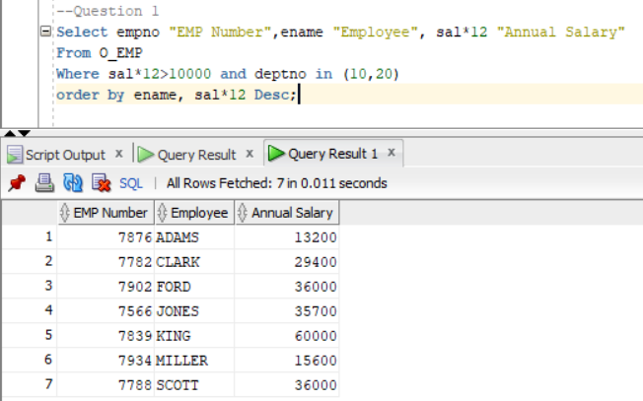

-- Question 2

-- Creating O_SALES view

CREATE VIEW O_SALES AS

SELECT C.NAME AS CUSTOMER, O.ORDID, O.ORDDATE, P.DESCRIPT AS PRODUCT, I.QTY, I.ACTPRICE

FROM O_CUSTOMER C, O_ORD O, O_ITEM I, O_PRODUCT P

WHERE C.CUSTID = O.CUSTID

AND O.ORDID = I.ORDID

AND I.PRODID = P.PRODID;

-- Example query to retrieve data from O_EMP table

SELECT * FROM O_EMP;

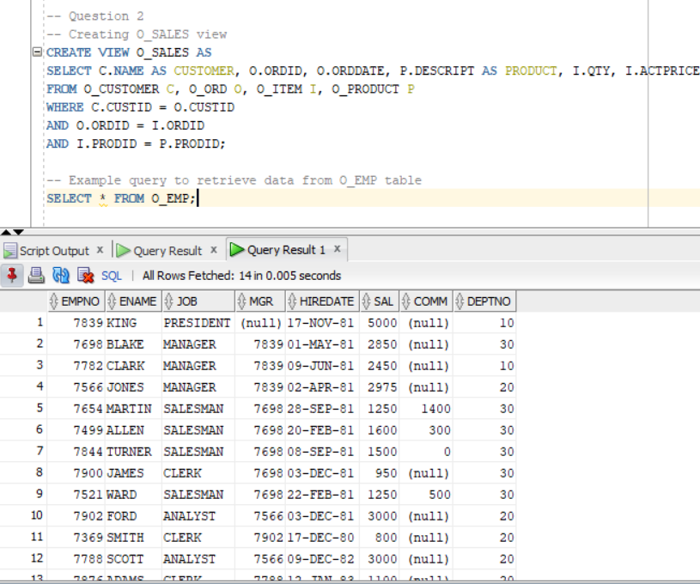

-- Question 3

SELECT

EMPNO AS "Employee Number",

ENAME AS "Employee Name",

JOB AS "Job Description",

EXTRACT(YEAR FROM HIREDATE) AS "Year of Employment",

EXTRACT(YEAR FROM SYSDATE) - EXTRACT(YEAR FROM HIREDATE) AS "Years Employed",

DNAME AS "Department Name"

FROM

O_EMP e

JOIN

O_DEPT d ON e.DEPTNO = d.DEPTNO

WHERE

e.DEPTNO IN (20, 30)

AND EXTRACT(YEAR FROM SYSDATE) - EXTRACT(YEAR FROM HIREDATE) > 29

ORDER BY

EMPNO;

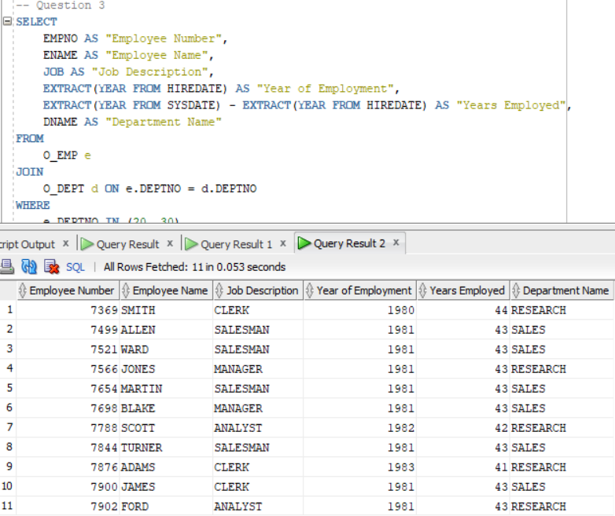

-- Question 4

-- Assuming job_description is entered as a placeholder:

VARIABLE job_description VARCHAR2(20);

EXEC :job_description := 'manager';

SELECT

e.EMPNO AS "Employee Number",

e.ENAME AS "Employee Name",

e.JOB AS "Job Description",

e.DEPTNO AS "Department Number",

d.DNAME AS "Department Name",

d.LOC AS "Location"

FROM

O_EMP e

JOIN

O_DEPT d ON e.DEPTNO = d.DEPTNO

WHERE

UPPER(e.JOB) = UPPER(:job_description)

ORDER BY

e.DEPTNO, e.ENAME;

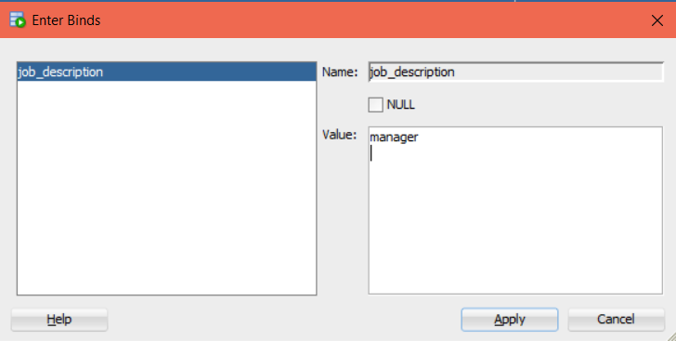

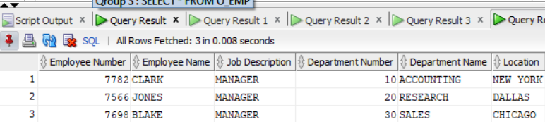

-- Question 5

UPDATE O_EMP

SET SAL = SAL * 3

WHERE DEPTNO = 30;

SELECT INITCAP(ename) || ' earns ' || TO_CHAR(sal, 'fm$99,999.00')

FROM O_EMP;

SELECT e.empno,

INITCAP(e.ename) AS name,

INITCAP(e.job) AS job,

INITCAP(d.dname) AS department_name,

INITCAP(d.loc) AS location

FROM O_EMP e

JOIN O_DEPT d ON e.deptno = d.deptno

WHERE e.sal < 0.2 * (SELECT sal

FROM O_EMP

WHERE INITCAP(job) = 'President');



-- Question 7

-- Define the monthly commission and total columns

COLUMN monthly_comm FORMAT $999,999.00

COLUMN total FORMAT $999,999.00

-- Suppress feedback messages

SET FEEDBACK OFF

SET PAGESIZE 30

-- Prompt user to enter the department number

ACCEPT deptno PROMPT 'Enter value for deptno: '

-- SQL query to generate the report

SELECT e.empno AS "Employee Number",

INITCAP(e.ename) AS "Name",

INITCAP(e.job) AS "Job",

INITCAP(d.dname) AS "Department Name",

INITCAP(d.loc) AS "Location",

e.comm AS "Monthly Commission",

e.sal + NVL(e.comm, 0) AS "Total"

FROM O_EMP e

JOIN O_DEPT d ON e.deptno = d.deptno

WHERE e.deptno = &deptno

ORDER BY e.empno;

-- Enable feedback messages again (optional, for further use)

SET FEEDBACK ON

The user is prompted to enter the Department Number:

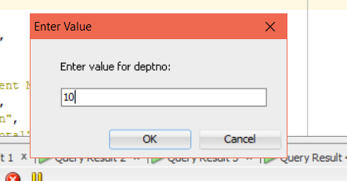

Output after entering the value:

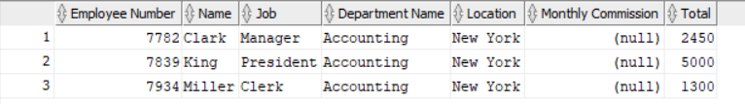

-- Question 8.1

-- Create the TRUCK table with the appropriate data types

CREATE TABLE TRUCK (

TRUCKNO NUMBER(8) NOT NULL,

CODE NUMBER(5),

MILES NUMBER(10,1),

BUYDATE DATE,

PRICE VARCHAR2(15),

SNO VARCHAR2(20)

);

-- Insert the provided data into the TRUCK table

INSERT INTO TRUCK (TRUCKNO, CODE, MILES, BUYDATE, PRICE, SNO)

VALUES (1001, 1, 32123.5, TO_DATE('11-AUG-94', 'DD-MON-YY'), 'R109,999.99', 'AA-322-12212-W11');

INSERT INTO TRUCK (TRUCKNO, CODE, MILES, BUYDATE, PRICE, SNO)

VALUES (1002, 1, 76984.3, TO_DATE('23-MAR-92', 'DD-MON-YY'), 'R299,000.99', 'AC-342-22134-Q23');

INSERT INTO TRUCK (TRUCKNO, CODE, MILES, BUYDATE, PRICE, SNO)

VALUES (1003, 2, 12346.6, TO_DATE('14-DEC-95', 'DD-MON-YY'), 'R189,500.99', 'AC-445-78654-Z94');

INSERT INTO TRUCK (TRUCKNO, CODE, MILES, BUYDATE, PRICE, SNO)

VALUES (1002, NULL, 76984.3, TO_DATE('23-MAR-92', 'DD-MON-YY'), 'R299,000.99', 'AC-342-22134-Q23');

INSERT INTO TRUCK (TRUCKNO, CODE, MILES, BUYDATE, PRICE, SNO)

VALUES (1004, 3, 32012.3, TO_DATE('16-AUG-93', 'DD-MON-YY'), 'R150,000.00', 'AA-324-09823-Y65');

INSERT INTO TRUCK (TRUCKNO, CODE, MILES, BUYDATE, PRICE, SNO)

VALUES (1005, 3, 44213.6, TO_DATE('10-SEP-94', 'DD-MON-YY'), 'R175,600.00', 'KR-559-22189-K33');

Select * from TRUCK

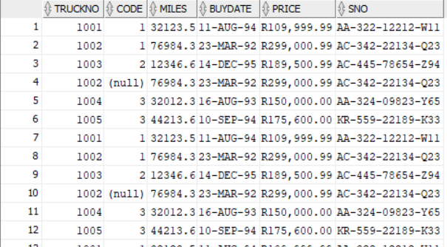

-- Question 8.2

-- Create the CAR_INFO table with the appropriate data types

CREATE TABLE CAR_INFO (

SNO VARCHAR2(20) NOT NULL,

MAKE VARCHAR2(20),

MODEL VARCHAR2(20),

REGNO VARCHAR2(15),

COLOUR VARCHAR2(10)

);

-- Insert the provided data into the CAR_INFO table

INSERT INTO CAR_INFO (SNO, MAKE, MODEL, REGNO, COLOUR)

VALUES ('AA-322-12212-W11', 'RENAULT', 'PNS600', 'FMT 276 GP', 'RED');

INSERT INTO CAR_INFO (SNO, MAKE, MODEL, REGNO, COLOUR)

VALUES ('AC-342-22134-Q23', 'MERCEDES', 'T100', 'SZX 067 L', 'WHITE');

INSERT INTO CAR_INFO (SNO, MAKE, MODEL, REGNO, COLOUR)

VALUES ('AC-445-78654-Z94', 'TOYOTA', 'DYNA S3', 'THU 118 MP', 'RED');

INSERT INTO CAR_INFO (SNO, MAKE, MODEL, REGNO, COLOUR)

VALUES ('KR-559-22189-K33', 'TOYOTA', 'CONV', 'DWR 286 NW', 'SILVER');

INSERT INTO CAR_INFO (SNO, MAKE, MODEL, REGNO, COLOUR)

VALUES ('AA-324-09823-Y65', 'MERCEDES', 'TS800', 'PZV 296 GP', 'SILVER');

INSERT INTO CAR_INFO (SNO, MAKE, MODEL, REGNO, COLOUR)

VALUES ('FR-998-32245-W12', 'DAIHATSU', 'J3', 'CA 135567', 'WHITE');

INSERT INTO CAR_INFO (SNO, MAKE, MODEL, REGNO, COLOUR)

VALUES ('DE-887-98456-E94', 'IVECO', 'TTK100S', 'TP 23469', 'RED');

Select * from CAR_INFO

-- Question 10.1

ALTER TABLE TRUCK MODIFY PRICE NUMBER(10,2);

Select * from TRUCK

-- Question 10.2

ALTER TABLE TRUCK ADD remark VARCHAR2(20);

UPDATE TRUCK

SET remark = 'NOT FOR SCRAPPING'

WHERE MILES <= 45000;

Select * from TRUCK

-- Question 10.3

DELETE FROM TRUCK

WHERE TRUCKNO = 1002 AND SNO IS NULL;

Select * from TRUCK

-- 11.1 Set primary keys

ALTER TABLE TRUCK ADD CONSTRAINT PK_TRUCK PRIMARY KEY (TRUCKNO, SNO);

ALTER TABLE CAR_INFO ADD CONSTRAINT PK_CAR_INFO PRIMARY KEY (SNO);

-- 11.2 Ensure columns are not null

ALTER TABLE TRUCK MODIFY TRUCKNO NUMBER(8);

ALTER TABLE TRUCK MODIFY SNO VARCHAR2(20);

ALTER TABLE CAR_INFO MODIFY SNO VARCHAR2(20);

-- 11.3 Add constraints for valid values

-- Add the check constraint after cleaning up data

ALTER TABLE CAR_INFO ADD CONSTRAINT CHK_CAR_COLOR CHECK (COLOUR IN ('GOLD', 'SILVER', 'WHITE'));

-- Find existing constraints on the TRUCK table

SELECT CONSTRAINT_NAME FROM USER_CONSTRAINTS WHERE TABLE_NAME = 'TRUCK';

-- Add a new constraint with a unique name

ALTER TABLE TRUCK ADD CONSTRAINT CHK_TRUCK_CODE_NEW CHECK (CODE IN (1, 2, 3));

-- 11.4 Add foreign key constraint

ALTER TABLE TRUCK ADD CONSTRAINT FK_TRUCK_SNO FOREIGN KEY (SNO) REFERENCES CAR_INFO (SNO);

-- 12.1 Create the sequence

CREATE SEQUENCE truck_seq

START WITH 1006

INCREMENT BY 1

MAXVALUE 9999

NOCYCLE

CACHE 20;

-- 12.2 Insert new truck information using the sequence

INSERT INTO TRUCK (TRUCKNO, CODE, MILES, BUYDATE, PRICE, SNO)

VALUES (truck_seq.NEXTVAL, 2, 93245.9, TO_DATE('27-DEC-1995', 'DD-MON-YYYY'), 269000.00, 'FR-998-32245-W12');

-- 12.3 Create a synonym for the sequence

CREATE SYNONYM tk FOR truck_seq;

-- 13.1 Remove all code 3 information from the TRUCK table

DELETE FROM TRUCK WHERE CODE = 3;

-- 13.2 Remove the TRUCK table from the system

DROP TABLE TRUCK;

-- 13.3

DROP TABLE truck_fin;

-- If truck_fin is a synonym

-- DROP SYNONYM truck_fin;

-- 13.4

DROP TABLE newtruck;

-- If newtruck is a synonym

-- DROP SYNONYM newtruck;

-- 14.1

DROP SEQUENCE truck_seq;

-- 14.2 Remove the database object created in 12c (tk)

DROP SYNONYM tk;